

LAB EXPERIMENT RECORD

SET 23

Department | Artificial Intelligence and Data Science
Course Code / Course Name | DSA0601 / Data Handling and Visualization
Name / Register Number | ROHAN P T / 192424112
Date / Day | 15/10/2026

Aim
To analyze employee performance analysis using the requested visualizations and dashboard views.

Dataset
Employee Performance Analysis
Employee_ID | Department | Years_of_Service | Performance_Score
1 | Sales | 5 | 85
2 | HR | 3 | 92
3 | Marketing | 7 | 78
4 | Sales | 4 | 90
5 | HR | 2 | 76

R Data Setup
Run this setup once before the R programs below. The dataset is defined inline so each record can be copied and run without a separate CSV file.
R data setup
dat <- data.frame(
Employee_ID = c(1, 2, 3, 4, 5),
Department = c("Sales", "HR", "Marketing", "Sales", "HR"),
Years_of_Service = c(5, 3, 7, 4, 2),
Performance_Score = c(85, 92, 78, 90, 76)
)

PROGRAM 1: Department Distribution
Create a labeled bar chart of employee counts by department.
R code
counts <- table(dat$Department)
barplot(counts, col="skyblue3", xlab="Department", ylab="Count", main="Employee Count by Department")

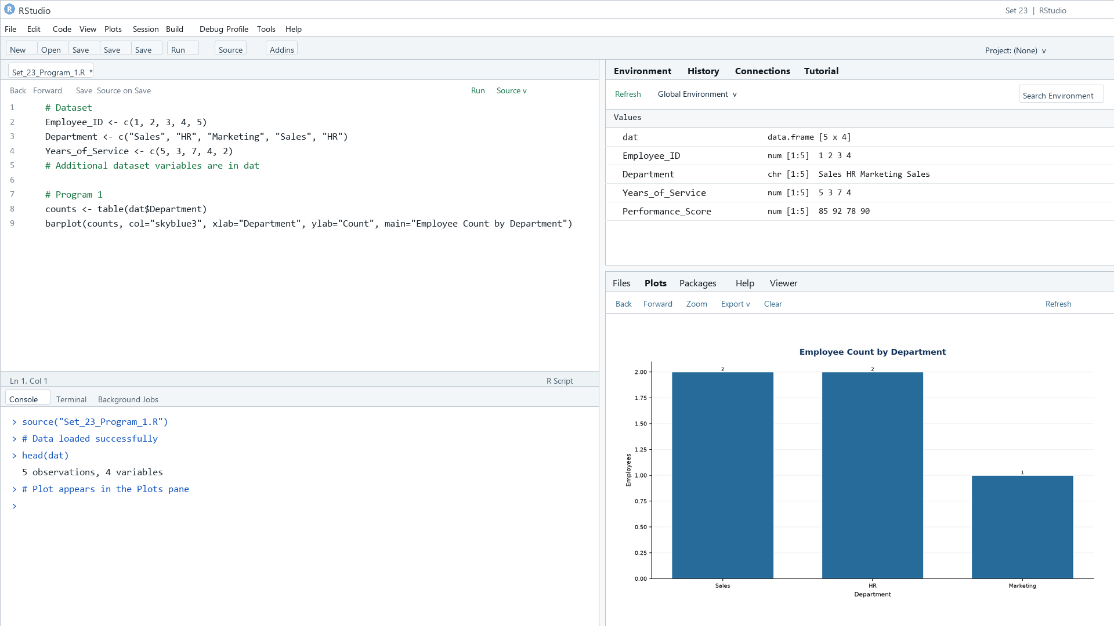
Output 1: Department Distribution
Observation: Sales and HR each contain two employees; Marketing contains one.

PROGRAM 2: Employee Performance Scores
Create a labeled line chart of employee performance scores. Use employee ID because no time variable is available.
R code
plot(dat$Performance_Score, type="o", xaxt="n", xlab="Employee ID", ylab="Performance score", main="Performance Score by Employee", col="#276B9A")
axis(1, at=seq_len(nrow(dat)), labels=dat$Employee_ID)

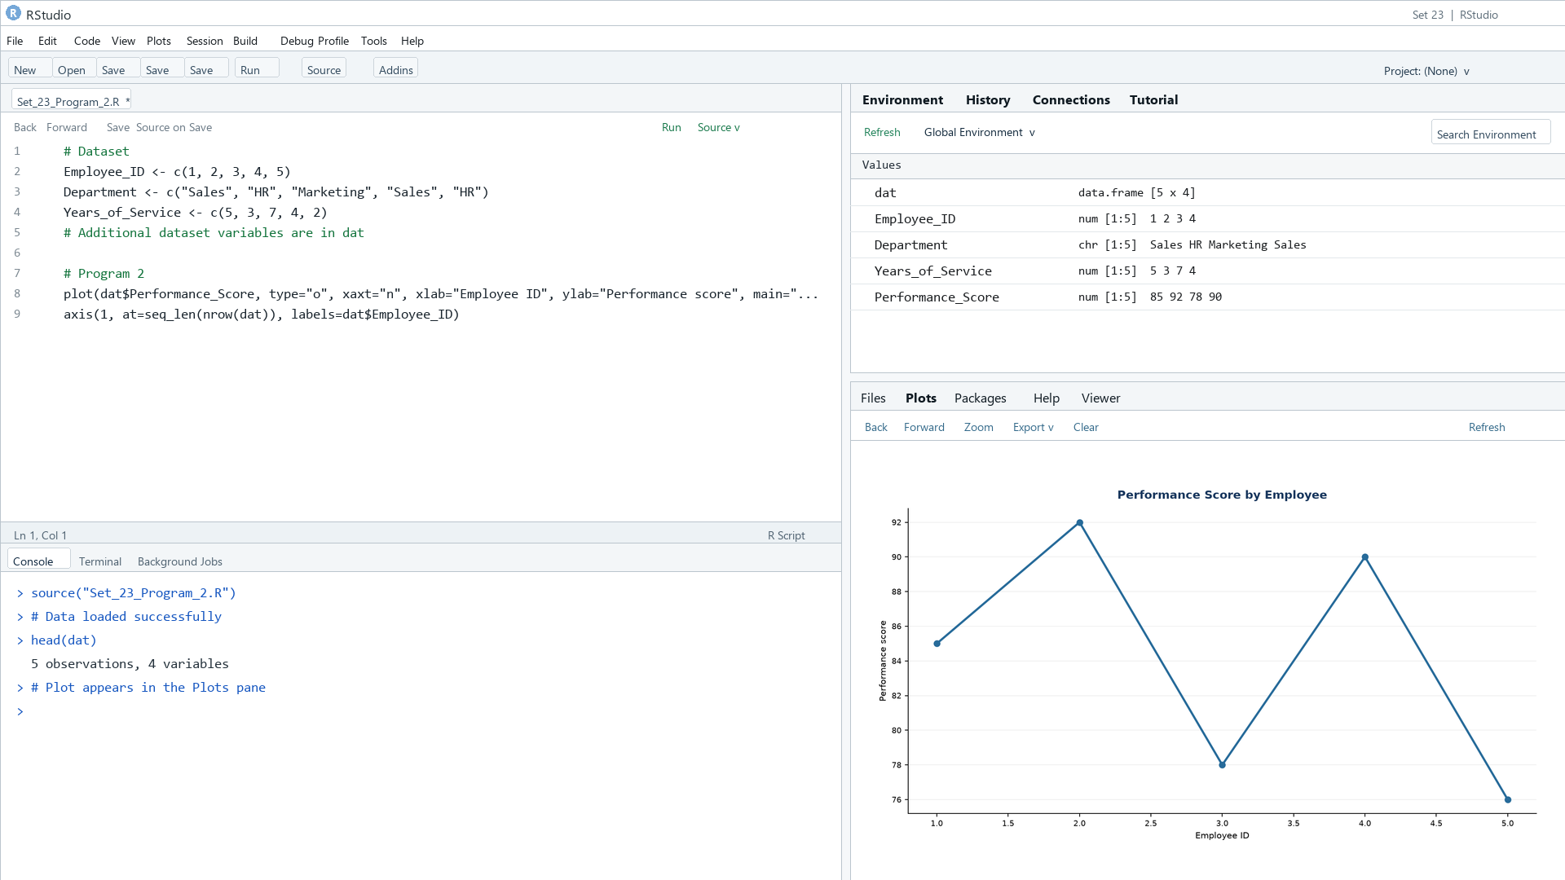
Output 2: Employee Performance Scores
Observation: Employee 2 has the highest listed score (92), while Employee 5 has the lowest (76). This is not a temporal trend.

PROGRAM 3: Employee Performance Dashboard
Create a Tableau dashboard with department counts and a scatter plot of years of service versus performance score.
Tableau build steps
Tableau dashboard build
1. Connect to the employee performance table.
2. Create a department count bar chart.
3. Create a scatter plot with Years_of_Service on Columns and Performance_Score on Rows.
4. Add Department as color and filter, then combine the views on a dashboard.

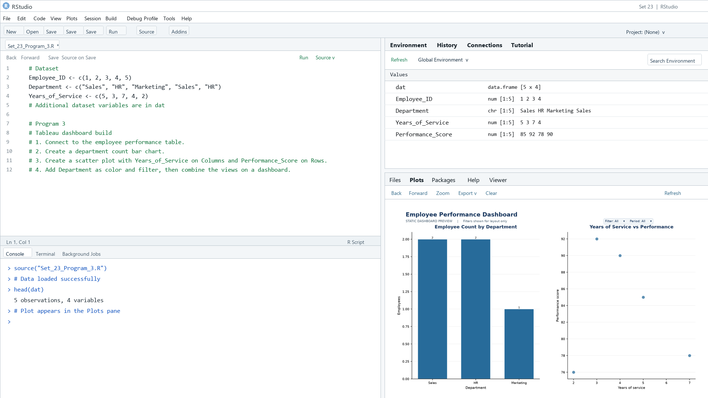
Output 3: Employee Performance Dashboard
Observation: The dashboard preview connects department counts to the service-score relationship. Department can be used as a filter.

PROGRAM 4: Employee Performance Data Table
Display the employee performance data in a labeled table.
R code
print(dat)

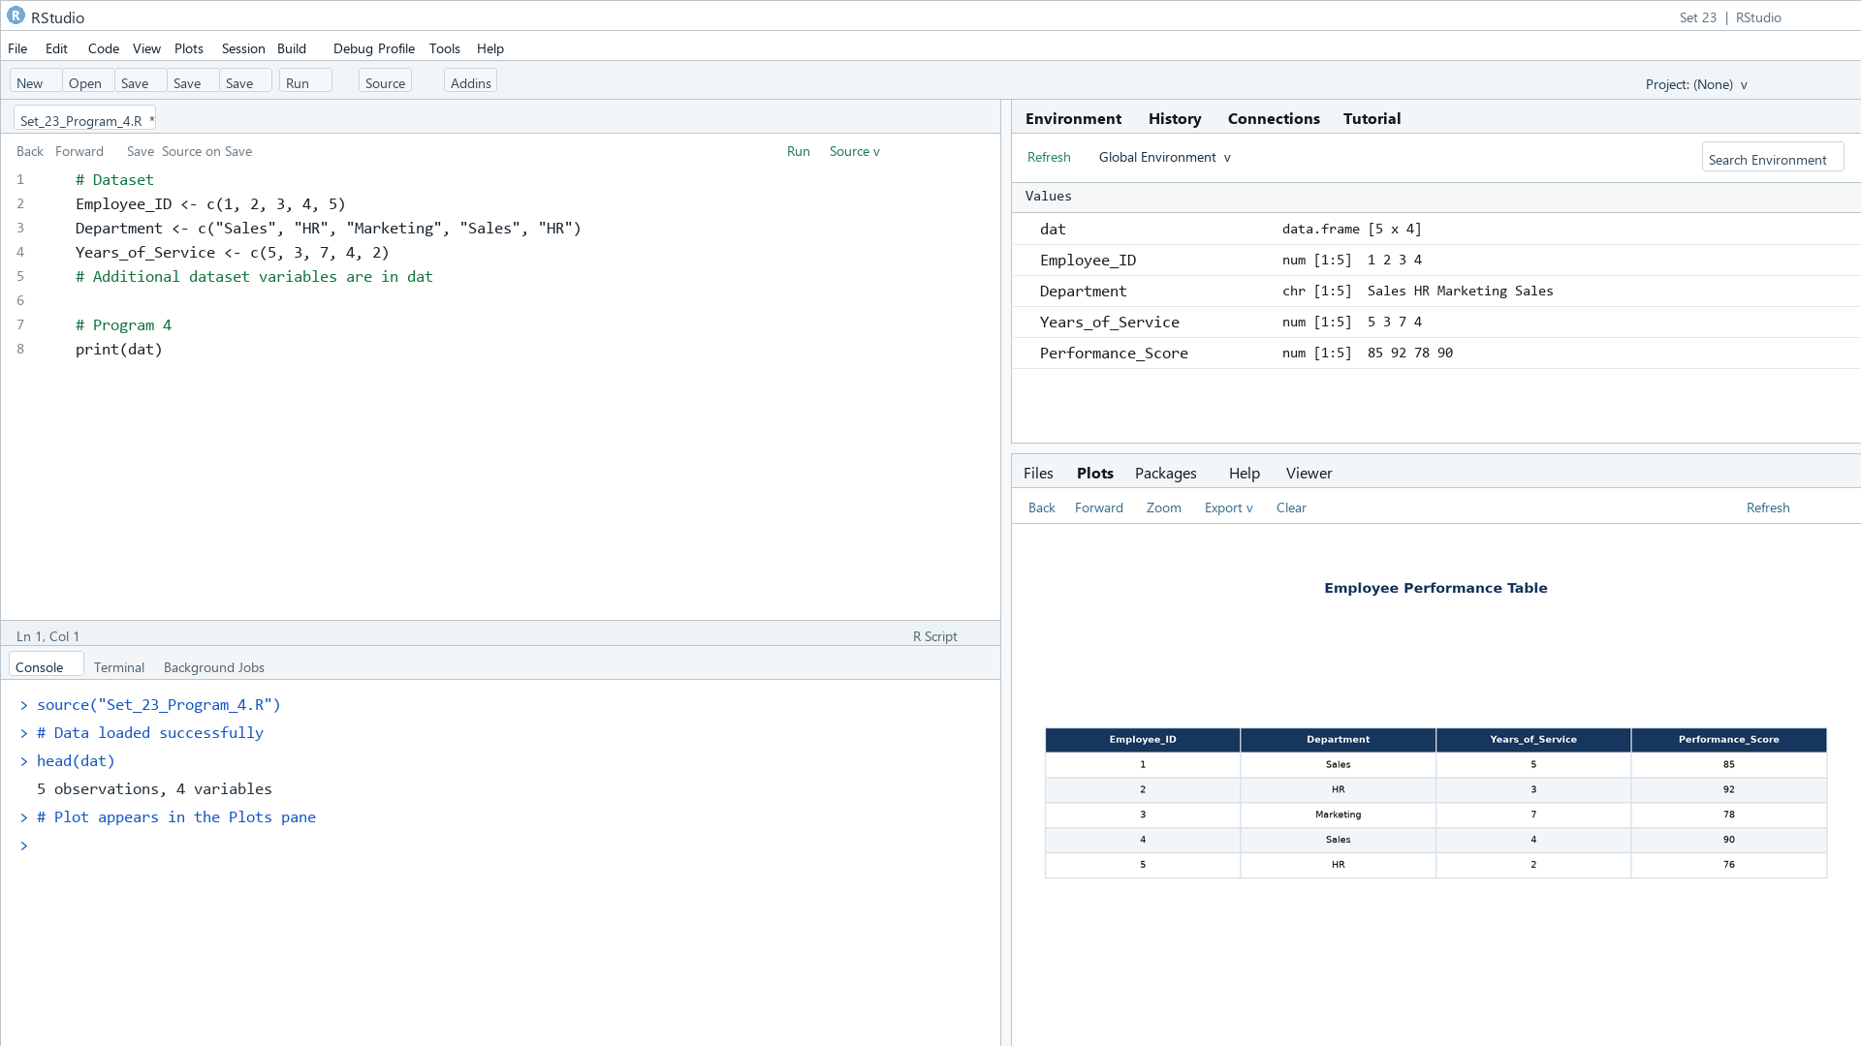
Output 4: Employee Performance Data Table
Observation: The table presents department, years of service, and score for all five employees.

Procedure
1. Review the dataset table and confirm any illustrative fields noted in the record.
2. Run the R setup block once, then run the requested program code.
3. Compare the output screenshot with the observation and replace illustrative values when actual data is available.
4. For Tableau tasks, connect to the displayed data and follow the dashboard build steps.

Result
The requested charts and dashboard views for Set 23 were prepared from the displayed dataset. Outputs include labels, short observations, and code or dashboard construction steps.

Key Functions Used
plot(), barplot(), hist(), boxplot(), table().

